Building a Docker image with Dockerfile

#make Directory

>> mkdir Test

>> cd Test

>>nano dockerfile

#inside the dockerfile—

FROM ubuntu

RUN apt update -y

RUN apt install nginx -y

RUN cd /var/www/html

RUN rm index.html

RUN touch index.html

RUN echo "hello From Kalpesh..!" > index.html

CMD ["nginx", "-g","daemon off;"]

#save file

#to build image

>> docker build .

#To mapping the port

>> docker run -d -p80:80 fe5bdf6c7f52

#docker image building

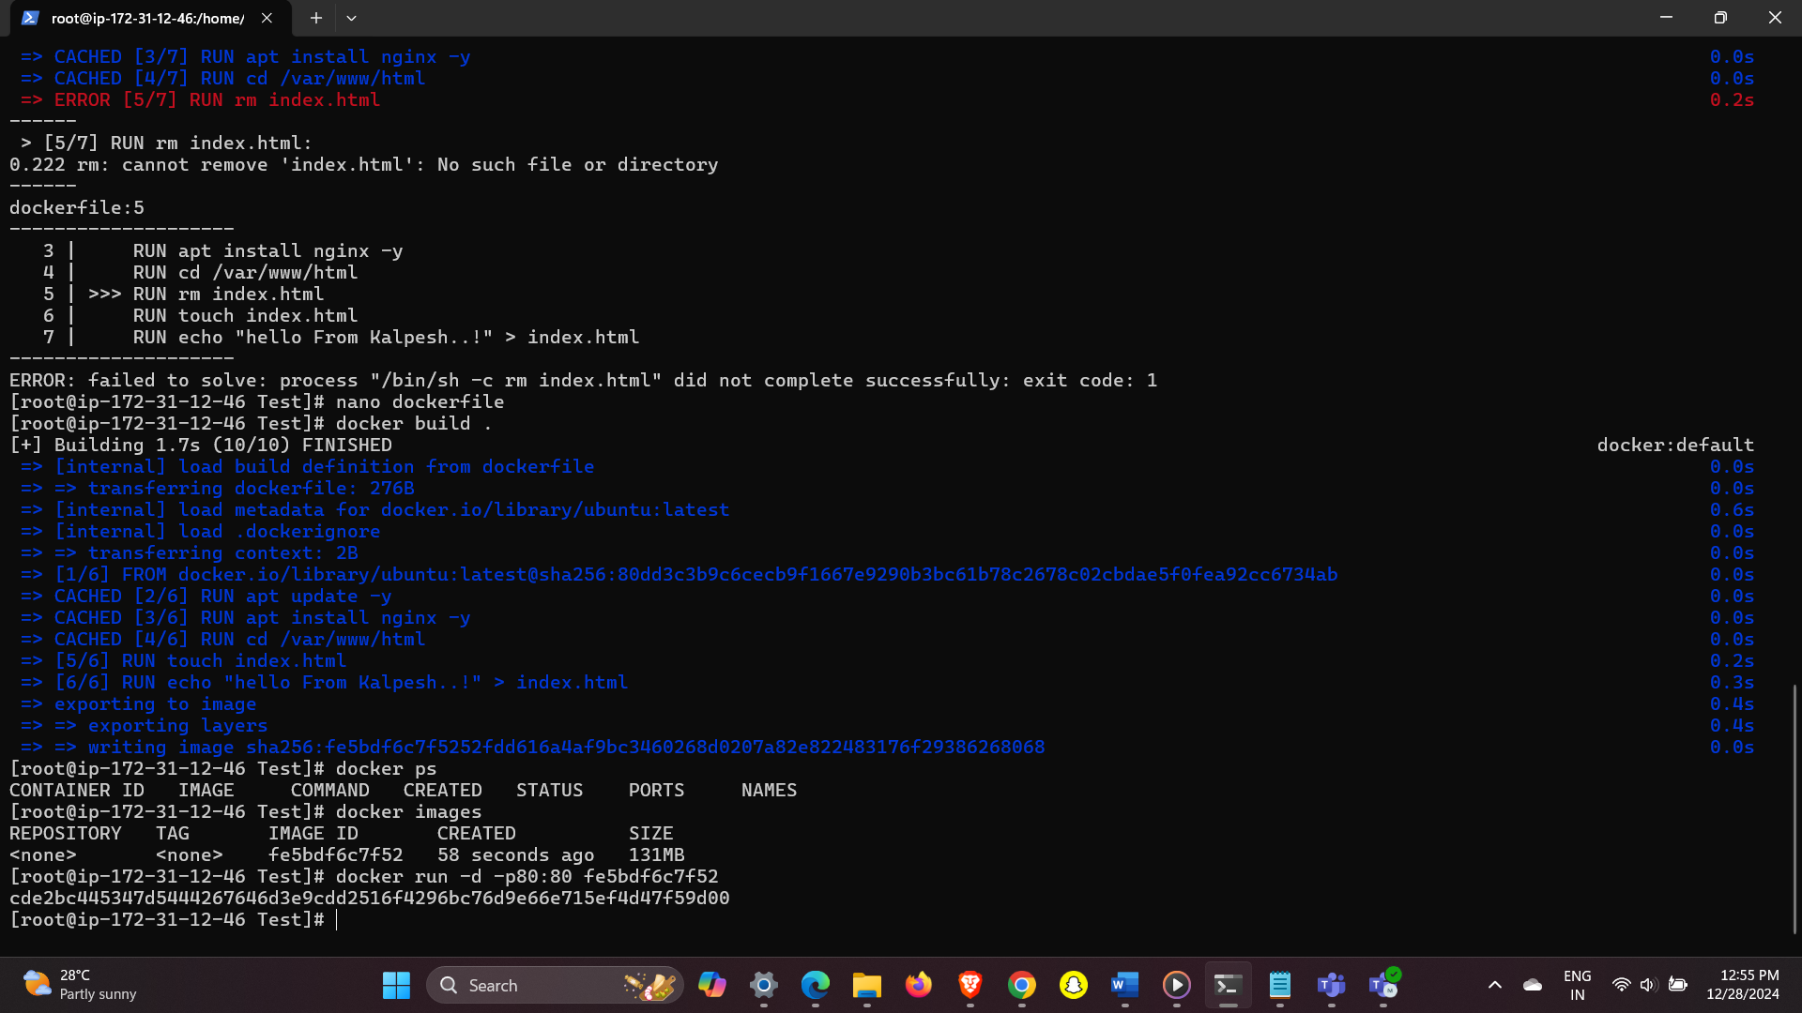

#output Successfully install nginx

